|  |  |  |
| --- | --- | --- |
| **Telecommunication Development Sector**  **Study Groups** | | P:\SUP\Logos\Post-150th Anniv\ITU-logo-UNblue.jpg |
| **ITU-D Study Group 2 Rapporteur Group Meetings** | | |
| **Geneva, 7 – 18 October 2019** | | |
|  | |  |
|  | | **Document** [**SG2RGQ/187-E**](http://www.itu.int/md/D18-SG02.RGQ-C-0187/) |
| **24 September 2019** |
| **English only**  **DELAYED CONTRIBUTION** |
| Question 1/2: Creating smart cities and society: Employing information and communication technologies for sustainable social and economic development | | |
| SOURCE: | NEC Corporation (Japan) | |
| TITLE: | Feasibility study result: sustainable smart society with information communication infrastructure and data utilization software | |
| Reference to Document: [SG2RGQ/28](https://www.itu.int/md/D18-SG02.RGQ-C-0028/), [2/208](https://www.itu.int/md/D18-SG02-C-0208/) | | |
| Action required: | Participants are invited to consider this document. | |
| *Keywords:* | *IoT sensor, smart city and society, CATV, SDN, data utilization software* | |

|  |
| --- |
| **Abstract:**  This contribution introduces concrete results of a feasibility test conducted in Shiojiri City, Japan, where they have been trying to build the infrastructure of a sustainable smart city. In this feasibility study, in order to make the environmental sensor data more effective, data utilization software is used and Software Defined Networks (SDN) technologies are applied to the city’s information communication infrastructure (CATV). This use case will explain how this solved issues for local residents and communities. |

1. **Introduction**

The use case of automatic collection of environmental data with IoT sensors in Shiojiri City was presented to the ITU-D Study Group 2 Rapporteur Group Meeting (October 2018) in Document [SG2RGQ/28](https://www.itu.int/md/D18-SG02.RGQ-C-0028) ("Proposal for the sustainable smart society"). For further details on the background of Shiojiri City, please refer to this Document.

Shiojiri City conducted a feasibility study to effectively utilize environmental data from November 2018 to May 2019. Document [2/208](https://www.itu.int/md/D18-SG02-C-0208) (“Sustainable smart society with information communication infrastructure and data utilization software”, ITU-D SG2 meeting in March 2019) showed that the feasibility study of Shiojiri City was a good example that can solve problems of local residents and local communities by using data utilization software and by applying SDN technology to CATV network.

This contribution follows on from Document [2/208](https://www.itu.int/md/D18-SG02-C-0208) and introduces concrete results obtained in that feasibility study.

1. **Background of feasibility study**

In Document [2/208](https://www.itu.int/md/D18-SG02-C-0208), as a reference information for developing countries, the issues and solutions in Shiojiri City were explained as follows.

CATV operators play an important role as providers of information services for local and regional residents and communities and they have an issue that it is a requirement to realize sophisticated services while reducing the maintenance and operation costs. In response to this issue, SDN[1] technology was applied to CATV to minimize changes to the conventional CATV network and to achieve an advanced network deployment. Furthermore, the use cases illustrate that using SDN (that does not separate radio broadcasting and wired communication and adopts bidirectional communication) is a viable option for developing countries when planning and deploying communication infrastructure.

Next, when building new environmental sensor networks for smart cities, rather than separately collecting and managing databases divided into categories as in the past, it is possible to use data utilization software to share data across categories and provide value-added information for solving regional issues.

For example, it becomes possible to predict the likelihood of an occurrence of frost in an area from environmental data by using data utilization software. Warnings of possible frosts are sent to fruit farmers through the CATV network which is running on an SDN. In this way, producers can receive real-time forecasts of the probability of a frost and can take measures to minimize frost damage and reduce the serious local issues of frost damage of fruits.

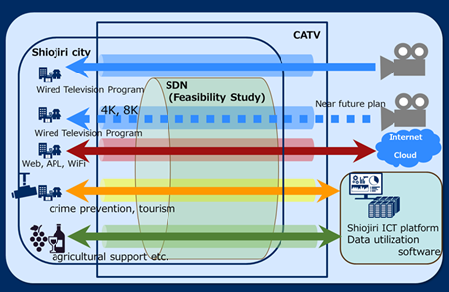

**Figure 1:** Feasibility study of CATV information communication infrastructure with SDN ([2/208](https://www.itu.int/md/D18-SG02-C-0208))

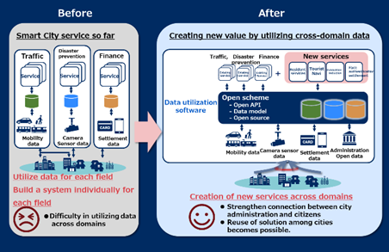

**Figure 2:** Feasibility study of data utilization software ([2/208](https://www.itu.int/md/D18-SG02-C-0208))

1. **Concrete results of the feasibility study**

The feasibility study in Shiojiri City, which ended in May 2019, looked using data utilization software and the application of SDN to the city’s information communication infrastructure (CATV). This study brought positive results and showed how these technologies can solve a number of issues for local residents and the community.

* 1. **Visualization of CATV communication traffic**

It was confirmed that the communication characteristics of each service/application can be visualized by the SDN technology when applied to the regional information communication infrastructure, the CATV network. It can be understood that the communication characteristics are different for each service, and it can be said that an appropriate communication environment is required for each service.

* 1. **Network control**

Since it became possible to analyse the communication status by visualization, it was confirmed that it is possible to perform network control for each terminal and each APL by using the function of SDN as needed. As a result, it can be said that the CATV network will be able to cope with more diverse and sophisticated communication services such as IoT and continue to play an important role of information communication infrastructure for local residents and communities in the future. Furthermore, it is possible to carry out efficient capital investment in the medium to long term by controlling not only the efficiency of daily operation of CATV but also the efficient use of bandwidth.

* 1. **Warning of frost occurrence**

In Shiojiri City, wine made from grapes is a growth industry. When a frost occurs between March and May, it has a major influence on the growth of fruit trees and will damage the harvest of an orchard. To tackle this, weather sensors were installed at 10 locations in the area where fruit cultivation was thriving on the south side of Shiojiri City, and data was collected every 30 minutes from sensors that constantly monitor the atmospheric temperature and atmospheric humidity. A data utilization software (FIWARE) accumulated these temperature and humidity data together with other environmental sensor data and geographical information. For each areas, the dew point was calculated from the temperature and humidity, and then these values were expressed in a graph for visualization.

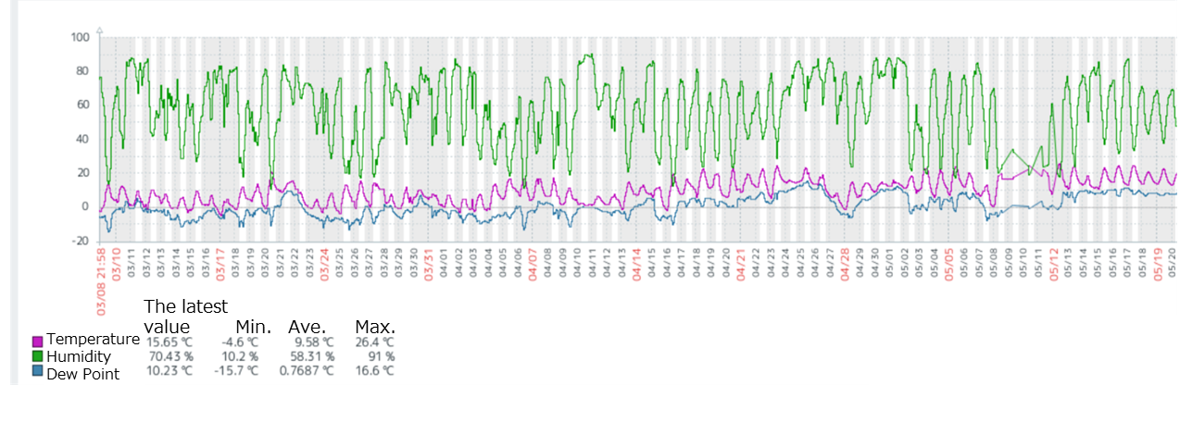**Figure 1:** Change in temperature, humidity and dew point of an orchard in Shiojiri City

In this area, there is know-how accumulated from the past that frost may occur if the temperature is close to the dew point and the time below 0 degree continues[2]. Based on this know-how, the data utilization software calculates the frost formation requirement into a numerical value, and predicts the likelihood of frost occurring in the next two hours for each orchard area, and then generates frost warnings.

* 1. **Reliable reporting of warnings to producers**

During the feasibility study period, the warning about the frost occurrence was actually reported six times by the data utilization software. The SDN network ensures that the bandwidth of the CATV network is always reserved for disaster warnings. In the study, all frost warnings, using the SDN reserved bandwidth, were confirmed as delivered to the farmers. Although frost occurred, farmers had received frost warning in real time and had been able to prevent damage and loss by taking preventive measures against frost. Effectively minimizing frost damage on fruit trees is a great benefit to producers.

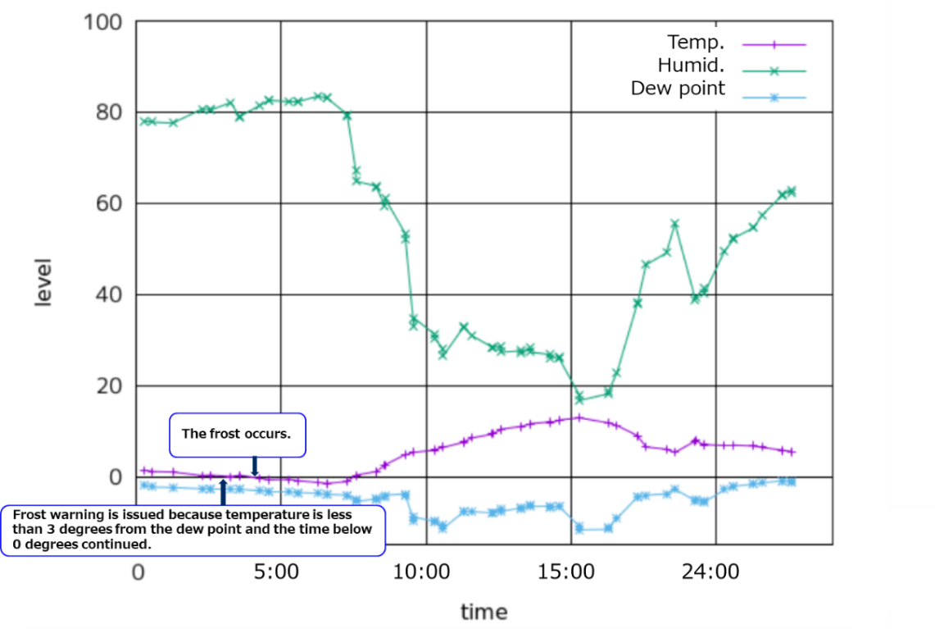

Figure 2: Frost occurrence on the 18th March, 2019 (Data at sensor#2A 10)

1. **Conclusion**

In Shiojiri City, fruit tree cultivation has been popular since ancient times, but farmers’ business have been plagued by frost damage for many years. This time, data utilization software has been used for predicting frost that in the past has relied on experience and intuition. Now it is possible to issue quantified hazard monitoring and warnings. In addition, the CATV network’s use of SDN made it possible for the delivery of farmers’ frost warnings to be guaranteed. This service led solution of regional problem in local industry.

It is proposed that the outcome from the feasibility study be included in the Final Report of Question 1/2.

This contribution was gratefully supported by Mr [Haruo Kaneko](mailto:hk@shiojiri.com) from Shiojiri City Hall (Japan);

_______________

1. ____________________ SDN device was jointly developed by NEC Networks & System Integration Corporation, the National Institute of Information and Communications Technology, and Professor Akihiro Nakao from the University of Tokyo.
2. ____________________ The results of dew point calculations are specific to the Shiojiri City, but the underlying algorithm may be applicable to other countries or regions.