|  |  |  |
| --- | --- | --- |
| **Telecommunication Development Sector**  **Study Groups** | | P:\SUP\Logos\Post-150th Anniv\ITU-logo-UNblue.jpg |
| **ITU-D Study Group 2 Rapporteur Group Meetings** | | |
| **Geneva, 7 – 18 October 2019** | | |
|  | |  |
|  | | **Document** [**SG2RGQ/173-E**](http://www.itu.int/md/D18-SG02.RGQ-C-0173/) |
| **19 September 2019** |
| **English only**  **DELAYED CONTRIBUTION** |
| Question 1/2: Creating smart cities and society: Employing information and communication technologies for sustainable social and economic development  Question 6/2: ICTs and the environment | | |
| SOURCE: | Shinshu University (Japan) | |
| TITLE: | Development of technology to solve pine blight countermeasure problems using drones | |
|  | | |
| Action required: | Participants are invited to consider this document. | |
| *Keywords:* | *drone, IoT, smart city, sensor network, image analysis, blockchain* | |

|  |
| --- |
| **Abstract:**  Shinshu University has signed a comprehensive cooperation agreement with Shiojiri City, Nagano Prefecture, and is working together to build a smart city in the city.  As part of these efforts, we have been working in various ways to resolve regional issues with ICT. In this contribution, we introduce the development status of image capturing technology and image analysis technology aiming at grasping the condition of pine wilt by taking a bird's-eye view from the air with a drone and taking countermeasures pinpointed. |

|  |
| --- |
| **Lessons learned and suggested best-practices (if appropriate):**  This time, we were able to build a series of systems from drone bird's-eye shooting to AI image determination.  As a result, the location of dead pine can be identified, and measures to prevent damage expansion can be performed at an early stage, and the efficient use of forest resources to cover the power necessary for the continuous maintenance of smart cities. We were able to take a big step toward building a usage cycle.  In addition, by measuring cracks and the like from the appearance of bridges, etc., we were able to grasp the state of unmeasurable cracks in high places and obtain materials for creating countermeasure plans.  By observing what has been disaster recovery after the landslides until now, it has become possible to develop landslide proactive measures one step earlier.  We will continue to build an efficient system in response to the decrease in the workable population due to the population decline, especially in response to the shortage of engineers and investigators, in accordance with the priorities as a means of solving regional issues. |

1. **Background**

Shiojiri City, Nagano Prefecture is a city with a population of 67,000 located in the central part of Japan. Shinshu University has been working on building a region using ICT based on the “Shinshu University / Shiojiri City Collaboration Project Research Institute”, which was established in 2003 in Shiojiri City, Nagano Prefecture through a comprehensive cooperation agreement with Shiojiri City. In particular, after the Niigata Chuetsu Earthquake that occurred in 2004, we worked to create a safe and secure area using ICT and developed a sensor network infrastructure. Using approximately 400 repeaters developed by Shinshu University in 2007, we have constructed and operated a sensor network relay network to support safe and secure life in the region. In addition, Shiojiri City has been expanded to include more than 600 repeaters and operated and maintained them as a sensor and relay network covering the entire city area of Shiojiri City. It is a sensor network advanced region that conducts research. It is also possible to manage the cycle of logging and planting forest timber from the construction of a biomass power plant that uses incineration heat of timber for the purpose of securing local power to continue to be a smart city.

In Japan, in the warm climate of the south western region for several decades (Figure 1), authorities chased countermeasures against the pine wood nematode called ‘Matsunosaisenchu’ (Figure 2).

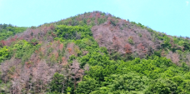

**Figure 1:** Forest with dead pine trees

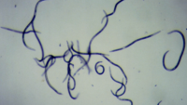

**Figure 2:** Pine wood nematode (foreign nematode)

Due to global warming, the damage has spread to relatively cold areas such as Nagano Prefecture that should not have been impacted in the past.

Shiojiri City is the forefront of the area where damage is starting to spread, and it is highly meaningful to stop the damage and secure wood that can be burned in this area. There is a strong demand to prevent further damage from spreading.

By identifying the spread of pine wilt caused by this alien nematode using ICT technology, the countermeasures were quickly implemented in a pinpoint manner to prevent the spread of damage to other regions.

1. **Technology required for drone image analysis technology**

The technical elements that we are developing are required for:

1. Bird's-eye photography

* Keep the distance from the subject being shot at regular intervals;
* The image should be taken as a video;
* Enable shooting for a long time.

1. Information processing after shooting

* Create bird's-eye view for location from video;
* Identify dead pine from still images by human work;
* Identify dead pine by AI;
* For the created file, specify the original in the blockchain.

1. **Development system**

This development[1] addresses the following four issues:

1. Efficiency improvement of forest management work (bird's-eye photography and image information processing by drone);
2. Extending life and preventing accidents by monitoring bridge abnormalities;
3. Improving disaster response work efficiency and lifesaving work efficiency;
4. Establishing a data utilization human resource development guidance model using Ideson etc.

In this contribution, we focused especially on (1) (Figure 3).

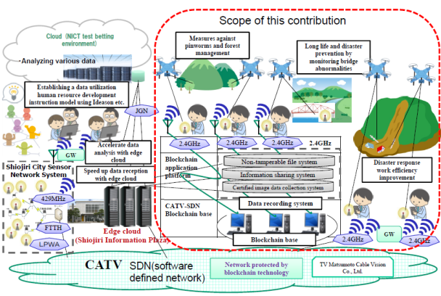

**Figure 3:** Development system

* 1. **Bird's eye view**

In order to make the drone fly at a constant altitude, and to capture the shooting altitudes that can be recognized by the Shiojiri city forest managers, three types of videos (30m, 50m, and 70m in height) were shot, and the videos were transmitted to the base station on the ground. One still image was taken out per second from the recorded moving image frame, and about 1,000 still images were created for each altitude in each region.

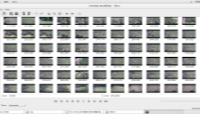 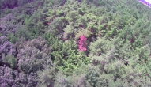 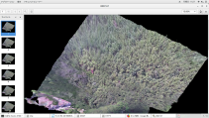

1. (b) (c)

**Figure 4**:   
(a) Still image cut out from video, (b) Withered red pine in the center, (c) Bird's eye view created

* 1. **Information processing after shooting**

Next, we performed orthorectification of the still image (converts the photo into an image displayed in the same position as when viewed from the top of the map), and created one bird's-eye view for each region by altitude. By creating a bird's-eye view, it is possible to identify the pinpoint location of the dead pine from the bird's-eye view created by the forest manager in Shiojiri City and go straight to the site, and carry out exterminating nematode removal processing in a short period of time.

* 1. **Automatic search for dead pine using AI**

Based on 3825 still images of teacher data created in advance as a learning material for AI to learn, a photograph with a dead pine is photographed and a photograph taken by a forest manager in Shiojiri City, and repeated to AI Learning is performed, and the presence/absence of a dead pine is determined from a newly created image, so that the determination by AI can be performed quickly. Once the image has been judged, the blockchain system obtains and stores the hash value of the file (which is obtained from the original data using a certain calculation procedure and is a fixed-length value with no regularity used for original matching). By doing so, it was saved in the system so that it could be proved at any time.

1. **Use for other solutions**

This photography technology can be used to judge the deterioration of public structures that are unreachable and to predict landslides in forests.

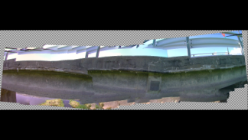

**Figure 5**: Side view of the bridge photographed and synthesized this time.

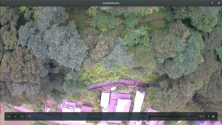

**Figure 6**: A photograph of the shape of a steep mountain forest that was taken this time to predict landslides in a mountain forest area.

1. **Conclusion**

This time, we were able to build a series of systems from drone bird's-eye shooting to AI image determination.

As a result, the location of dead pine can be identified, and measures to prevent damage expansion can be performed at an early stage, and the efficient use of forest resources to cover the power necessary for the continuous maintenance of smart cities. We were able to take a big step toward building a usage cycle.

In addition, by measuring cracks and the like from the appearance of bridges, etc., we were able to grasp the state of unmeasurable cracks in high places and obtain materials for creating countermeasure plans.

By observing what has been disaster recovery after the landslides until now, it has become possible to develop landslide proactive measures one step earlier.

We will continue to build an efficient system in response to the decrease in the workable population due to the population decline, especially in response to the shortage of engineers and investigators, in accordance with the priorities as a means of solving regional issues.

_______________

1. ____________________ These research results were obtained from the commissioned research by the National Institute of Information and Communications Technology (NICT) (Japan): “Research and development of information and communication technology for solving regional issues in the field of infrastructure maintenance, forest management, disaster response, lifesaving, and data utilization human resource development using medium-sized unmanned aircraft data utilization”.